**JAVA Assignment (Day - 1)**

1. **What is platform independent and dependent amongst jre, jdk and jvm ?**

All 3 are platform dependent.

1. JVM -> platform dependent.
2. JRE -> consists of JVM and some other things. Since it includes JVM, it is platform dependent.
3. JDK -> consists of JRE, compiler and some other things. Since it includes JRE which in turn includes JVM, it is platform dependent.

The java code before and after compilation is platform independent. You can compile on windows and run the byte code on unix using Unix's jvm.

1. **Can we use/ download JRE directly without using JDK ?**

Yes, we can use/ download JRE without JDK but only the bytecode will be executed while the java file will not be compiled.

While an employee works on some project, they need JDK for they need to write code as well as compile it. But after the development process completes, the software is ready to deliver and the client's machine will have to choose whether JDK is needed or the JRE.

It is recommended to install JRE on client's machines because clients don't have to compile the code. Clients always goes straight forward to execute it. It will give the advantage of Memory - Utilization too.

1. **Create a simple class “HelloWorld” and print “HelloWorld”.**

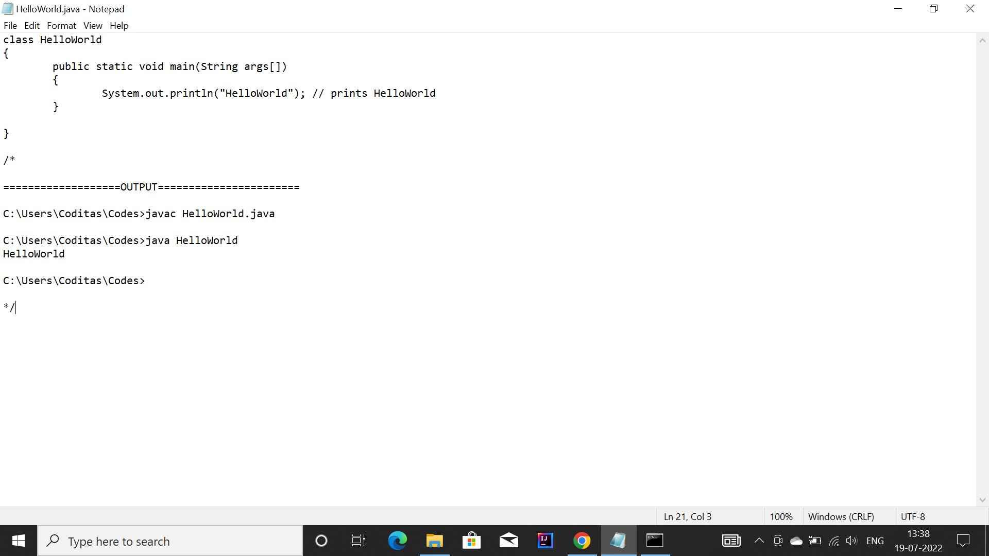

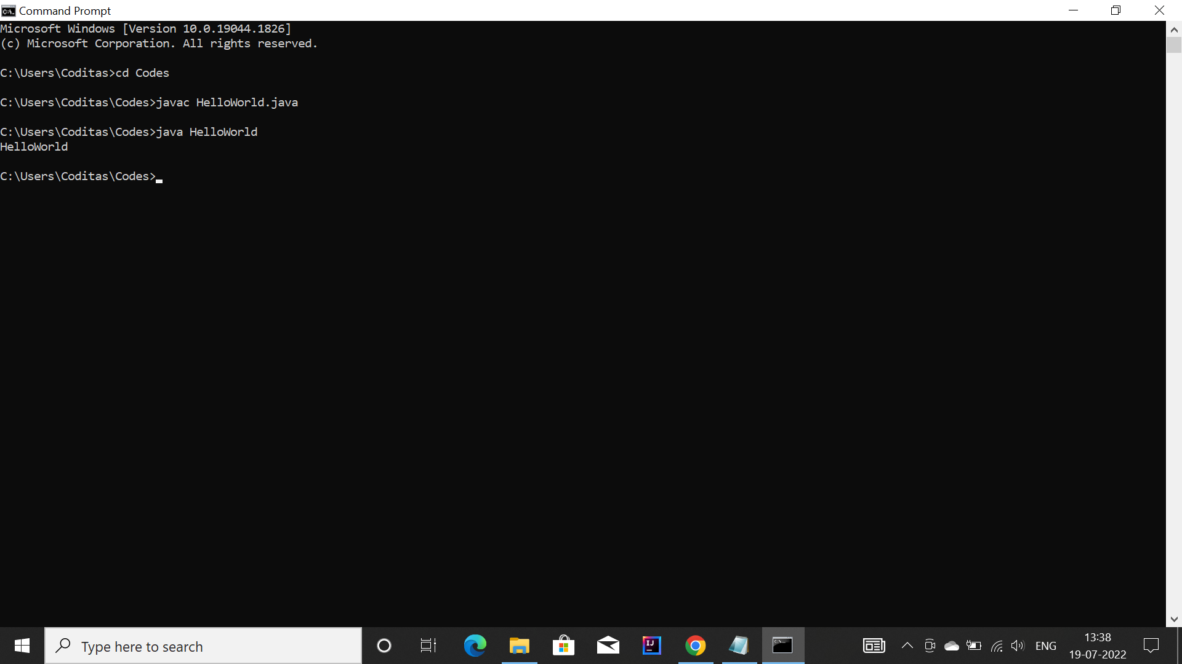

1. **Use the above mentioned class and save this file as “HelloWorld_Batch2.java” and try to execute the code. Add the execution commands with proper output.**

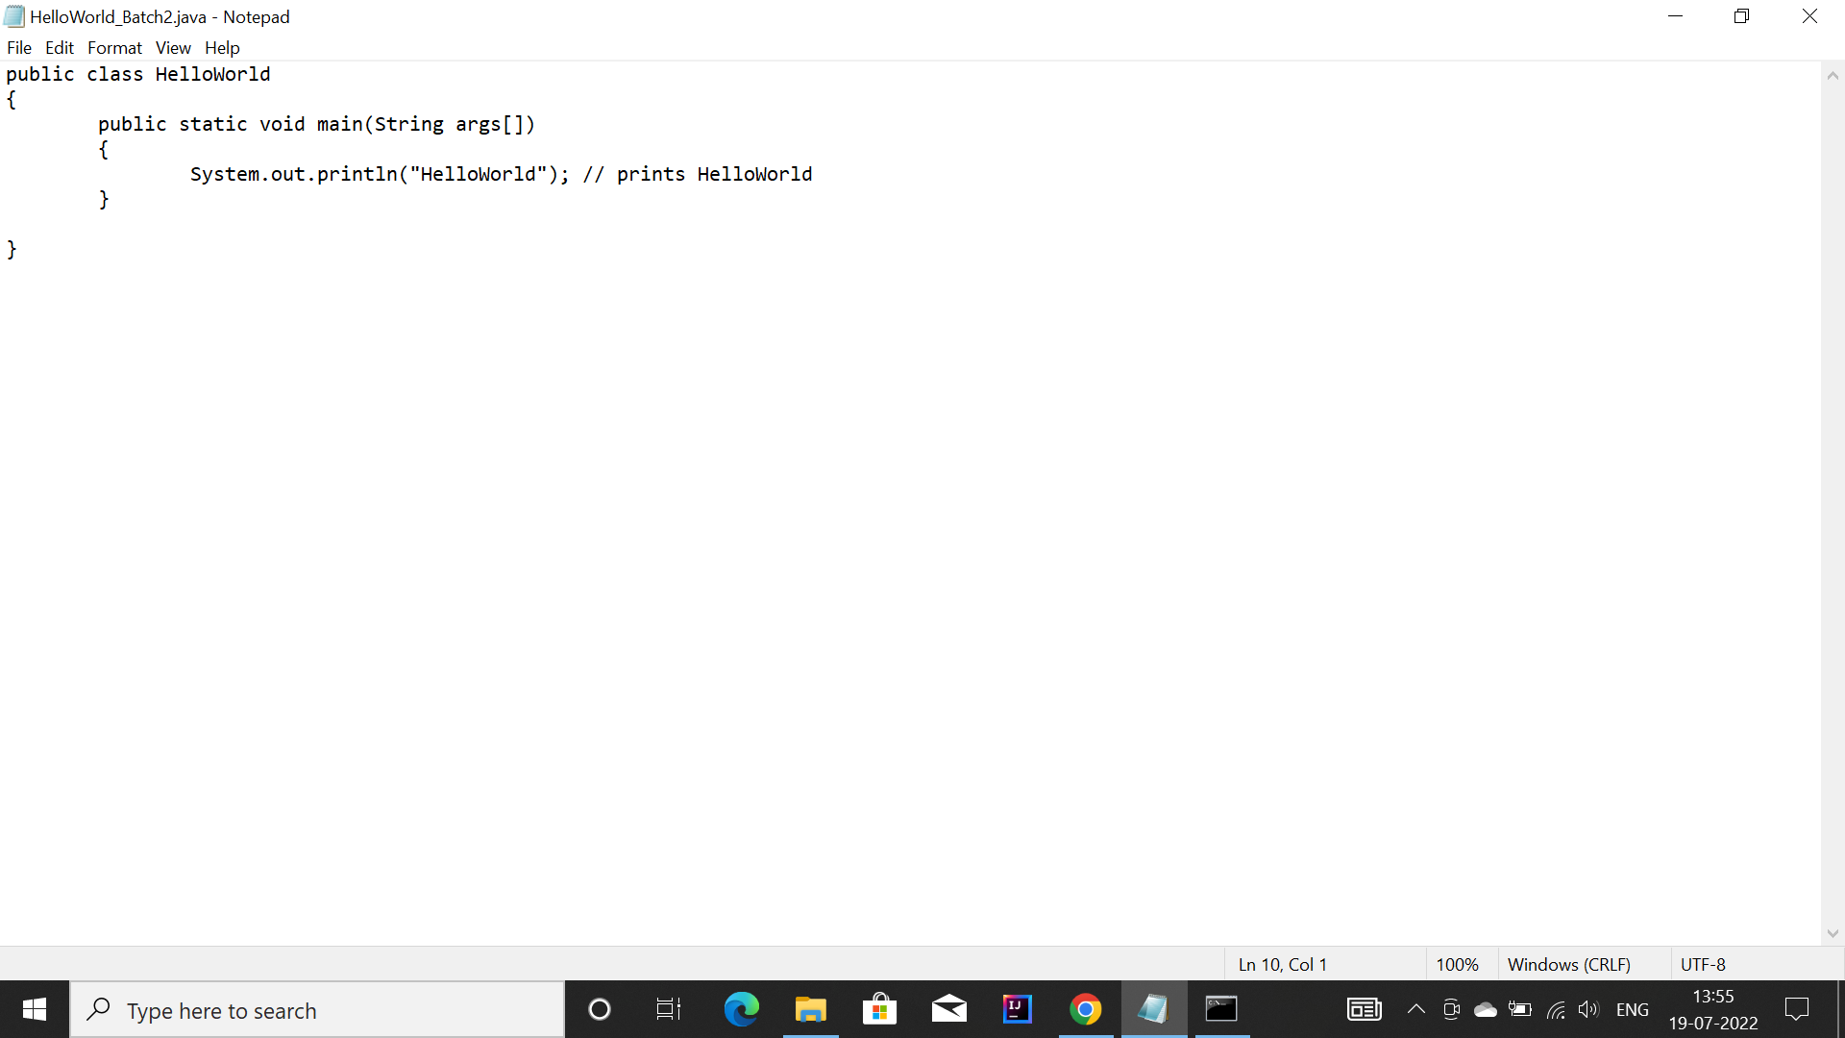

**For execution :**

1. Open command prompt

**javac HelloWorld_Batch2.java**

1. This runs javac.exe, the compiler. You should see nothing but the next system prompt.javac has created the HelloWorld.class file. You should see HelloWorld.java and HelloWorld.class among the files.

**java HelloWorld**

1. This runs the Java interpreter. You should see the program output

**Note :** As long as you don't have a public class in your source file, you can name your source file to any name and can compile. But, if you have a public class in your source file, that file should have the name same as your class name. Otherwise, compiler will throw an error.

**Case** : Notice that none of the classes are marked public therefore giving them default access. Files without any public classes have no file naming restrictions. Also, the object file is made for specific class and not for the file.

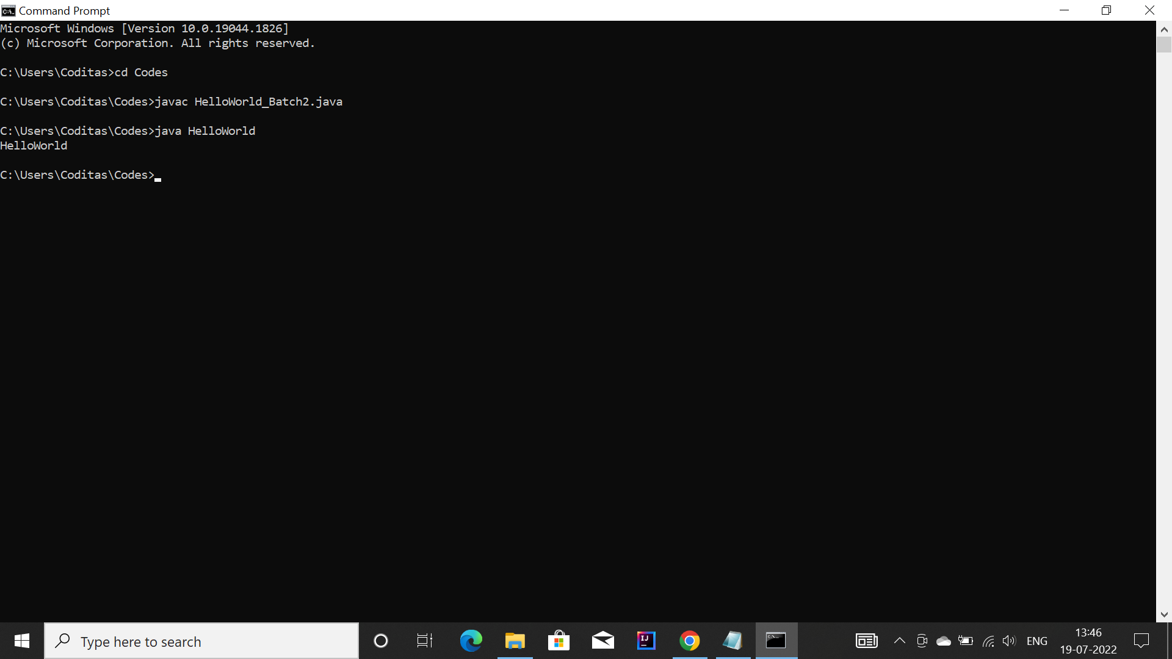

Else, will throw an error if tried to execute with file name.

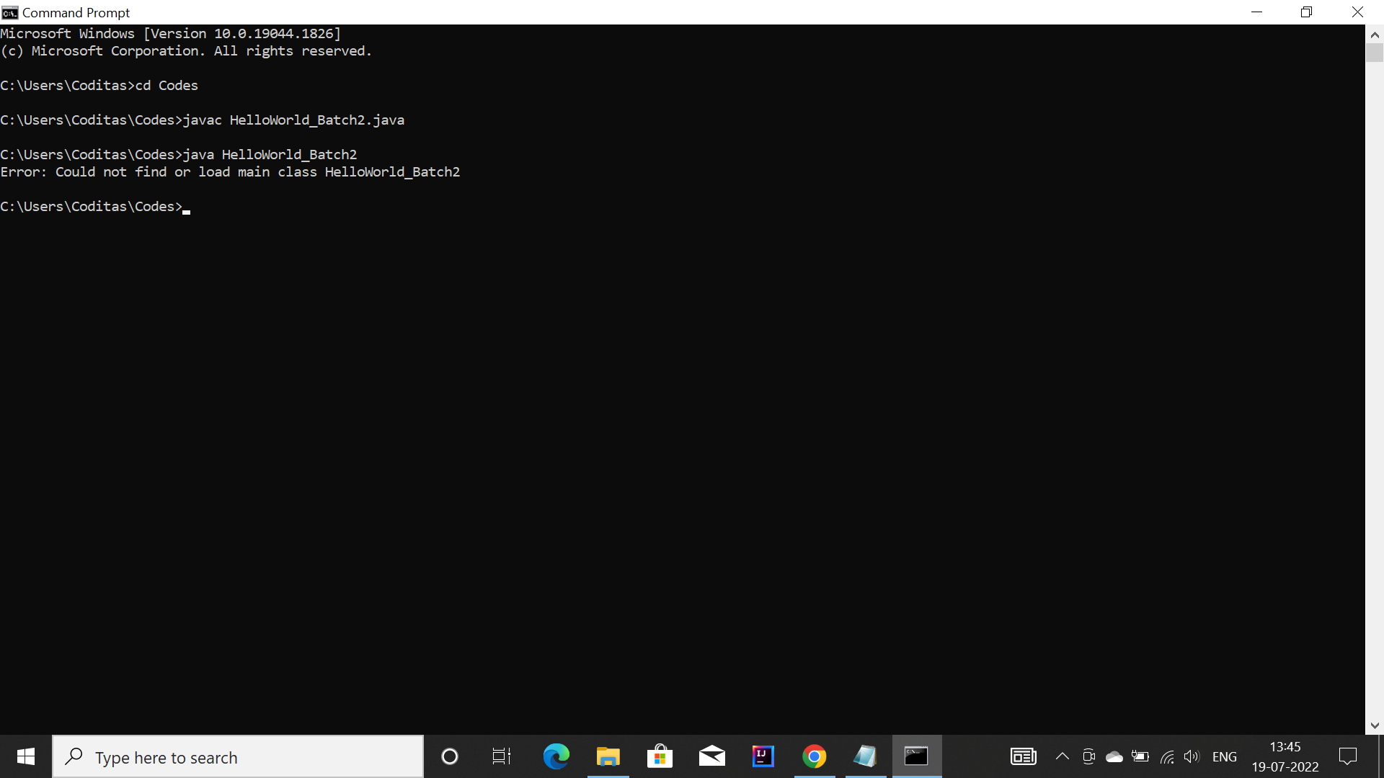

1. **Create a simple calculator program.**

